# Overview

Upon completion of this chapter, the participant will be able to:

* Learn how to use content management features, such as check in and check out.
* How to monitor project risks and issues with Project Site features.
* Create Deliverables linked to tasks.
* Learn the collaboration features of Project Sites.

# Managing Documents

It is important for the project team to have access to the latest project documents. Using Project Sites, project team members can update, save, store and share documents online. Document management is the key to safeguarding against project team members duplicating work. This ensures that projects are completed quickly and efficiently. SharePoint automatically adds a date and time stamp for document uploading and editing, making it easier to track document changes.

## Creating Document Libraries

Every project site contains a default document library called Project Documents. You can upload all project specific documents to this library. If needed, additional libraries can also be created to better organize documents. For example, if documents associated with your project are department specific, you can create one library for each department. A document library can contain multiple folders and documents, establishing easier navigation for grouping and locating documents.

Also on the PWA home page is a link for Shared Documents available where non project specific documents can also be uploaded. For example, the HR policy manual, department training material, etc. can be stored here.

To create a new document library:

1. Navigate to the desired Project Site.
2. Click the Site Contents option on the Quick Launch
3. Click add an app from the section labeled Lists, Libraries, and other Apps
4. Click Document Library

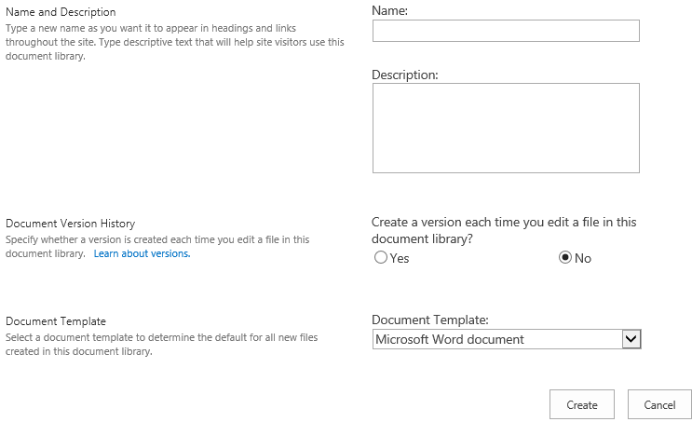

1. New Document Library [New Document Library.tif]
2. Click on Advanced Options
3. Give the new library a relevant Name and Description
4. In the Document Versions section, click No. Document versions should only be enabled for document libraries that will contain files that are developed over time.
5. In the drop down for Document Template, select None, this make it so that you can have whatever type of document you wish in this Library
6. Click Create.

A new link to the document library will now appear in the Quick Launch menu under the **Recent** heading.

## Uploading Documents

Any document type including Microsoft Word, Microsoft Excel, Microsoft Access, Adobe etc. can be uploaded to the document library. You can upload a single document or multiple documents at a given time. In addition to uploading existing documents, you can also create a new document directly from a library.

To upload a document to a document library:

1. Navigate to the desired document library in the Project Site.
2. In the library, click **new document**.
3. Alternatively, in the Files tab, New group, select Upload Document only if you want to upload one document.
4. In order to Upload Multiple Documents, drag multiple documents to the area next to **new document** labeled “or drag files here.”
5. Browse to the folder where your document(s) reside and click OK.

The document(s) will now appear in the library.

To create a new document:

1. Navigate to the desired document library in the Project Site.
2. In the Files tab, New group, click New Document.

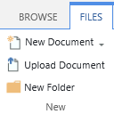

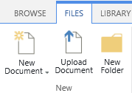

1. New Document Creation [New Document Creation Small.tif OR New Document Creation Large.tif]
2. A blank Word document will open up with an information bar listing the document properties.
3. Make all desired changes to the document and then from the File tab, choose Save.

The document will now be saved to the library.

## Editing Document Properties

Document properties are the metadata associated with documents that help in searching and organizing them within the Project Site. These attributes can be entered or edited through the Web or within Office Applications, like Word, Excel, or PowerPoint.

To edit document properties on the web:

1. Navigate to the desired document library in the Project Site.
2. Select the ellipsis next to the document title
3. In the Pop up menu, click the ellipsis again.
4. Select Edit Properties

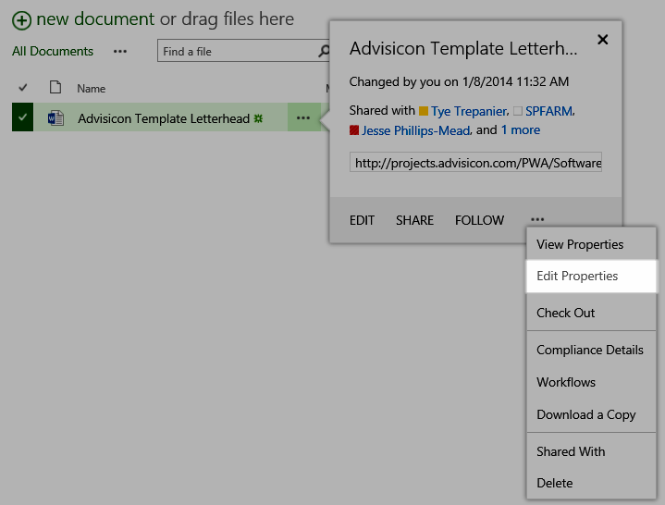

1. Editing Documents [Editing Documents.tif]

A dialog box with all the related document properties will open. You can now edit the properties.

To edit document properties within Office applications:

1. Navigate to the desired document library in the Project Site.
2. Open the document for editing in the respective Office application.
3. In the Office application, in the File tab, click Info.
4. In the properties section, on the right side of the Backstage View, open the Properties dropdown menu and choose Show Document Panel.

A document panel will appear in the document below the ribbon bar. This panel will allow you to edit all server based document properties.

## Enabling Document Versioning and Check In / Check Out

Document check in and check out controls the editing of documents by multiple people. It ensures that only one person can edit a document at a time. It allows users to have better control when a new version of a document is created and additionally, comment on changes made when a document is checked back in.

As a best practice to edit a document, you should first check out a document. This prevents anyone else from editing the document until you check the document back in.

During the period that a document is checked out, other users can view a read-only version of the document. Changes made while the document is checked out, will not be viewable until it is checked back in.

To check out a document in the document library:

1. Navigate to the desired document library in the Project Site.
2. Click the ellipsis to the right of the document title.
3. In the pop up menu, select the ellipsis again
4. In the dropdown menu, click Check Out.
5. Once the document is checked out, select the ellipsus next to the title of the document and select **EDIT**.

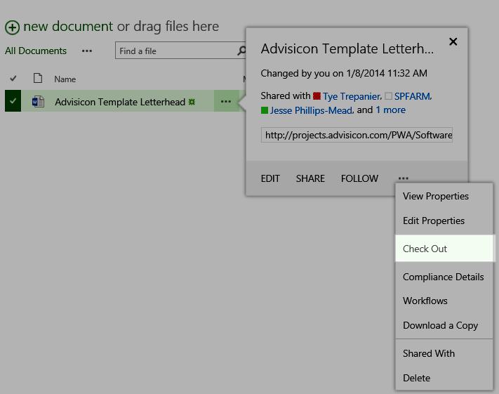

1. Checking Out Documents [Checking Out Documents.tif]

* After you have checked out a file, the Check Out option on the menu changes to Check In. You can use this option to check the file back in after you are done making changes.

While check in and check out limits the editing of documents to one person at a time, versioning takes care of keeping track of the changes made to documents. Versioning is the method by which successive iterations of a document are numbered and saved. It makes use of version numbers to track changes. For example, when a document is saved for the first time, it can be assigned version number 1.0. When it is edited and saved again, the version number is increased to 2.0.

To enable version control in a document library:

1. Navigate to the desired document library in the Project Site.
2. In the Library tab, Settings group, click Library Settings.
3. On the Document Library Settings page, in the General Settings section, click Versioning Settings.
4. On the Versioning Settings page, in the Document Version History section, select Create major versions if you only want to enable major versions on documents or select Create major and minor (draft) versions if you want both major and minor versions on documents, and click OK.

* Create major versions – each time a document is changed and saved, its version number will automatically increase by a whole number.
* Create major and minor (draft) versions – you must explicitly publish major versions through the Publish a Major Version menu option in SharePoint document libraries.

# Managing Risks and Issues

Using the Project Site feature, the project manager can keep track of risks and issues related to the project. It allows for capturing, tracking, assigning and monitoring of risks and issues.

A risk is always connected to uncertainty. When something becomes certain to occur, it is called an issue, instead of a risk. Issues are just as important as risks; issues are problems that occur during a project. If an issue is not managed, it can materially affect the successful completion of a project. Your issue list will not be perpetual, as your risk list will be. This is because issues will open and close as they are identified and resolved.

## Creating a New Risk Item

Project Server 2010 has pre-defined forms to identify and track risks. The project team can place risk items on the Project Site. Team members can assign risks, categorize them, prioritize them, and define a mitigation and contingency plan to resolve risks. The captured risk data will be stored in the organization’s historical information knowledge base and can be used to proactively mitigate similar risks in future projects.

To create a new risk item in the project site:

1. In the Quick Launch menu, click Projects
2. Select the project for which you want to create a new risk.
3. In the Project tab, Navigate group, click on Project Site.
4. In the Project Site under **Risks**, click New Item.
5. A new blank risk form will open. At a minimum, complete the required fields and click Save.

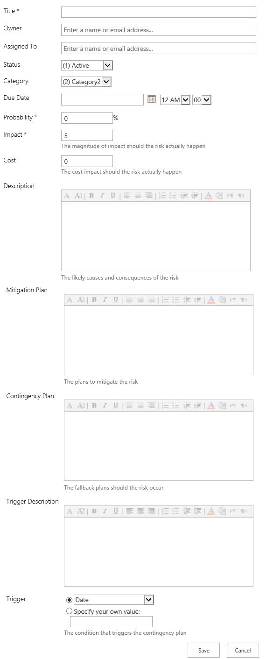

1. Risk Creation [ Risk Creation.tif]

* Title – defines the risk. This field is required.
* Assigned to – identifies the resource responsible for resolving the risk.
* Status – identifies the current status of the risk. By default Active, Postponed, or Closed status options are available.
* Category – describes the category of risk. The default categories are Category 1, Category 2, and Category 3. These categories can be customized to match the organization’s needs. Examples of categories are internal, external, vendors, etc.
* Due Date – identifies the date by which a risk should be resolved.
* Owner – identifies the name of the person responsible for tracking and managing a risk. The field defaults to the currently logged-on user.
* Probability – identifies the chance of a risk actually occurring, measured as a percentage. By default, a range of 1–100% is used to measure probability. This field is required.
* Impact – identifies the significance of the risk in terms of how it can affect the outcome of a project. By default, a range of 1-10 is used to measure impact. This field is required.
* Cost – identifies the estimated costs of a risk in terms of how it will affect the financial outcome of a project.
* Description – describes the likely causes of a risk and what the consequences of the risk might be.
* Mitigation Plan – describes the plans for mitigation of the risk.
* Contingency Plan – describes the fallback plans in the event that the risk occurs.
* Trigger Description – describes the trigger that will require the risk to have a contingency plan.
* Trigger – specifies the condition that will cause the risk to require a contingency plan.

## Creating a New Issue Item

Like risk forms, the Project Site also has predefined issue forms. Team members can assign issues, prioritize them, discuss the issue item and also describe the resolution plan to resolve the issues.

To create a new issue item in the project site:

1. In the Quick Launch menu, click Projects
2. Select the project for which you want to create a new issue.
3. In the Projects tab, Navigate group, click Project Site.
4. In the Project Site under Issues, click Add New Item.
5. A new blank issue form will open. At a minimum, complete the required fields in the and click Save.

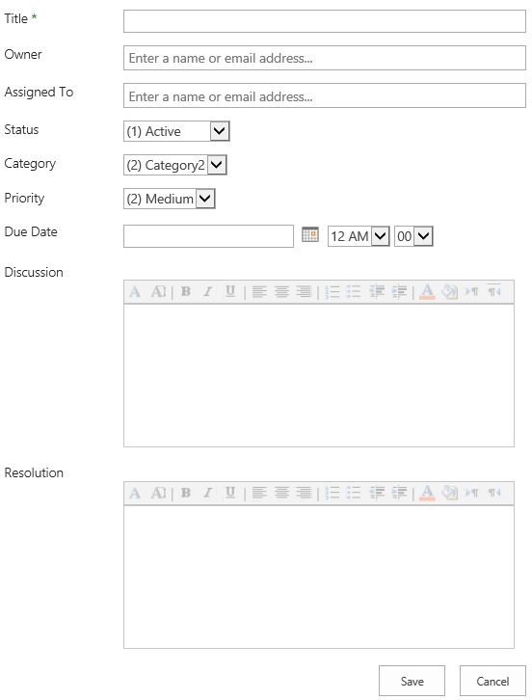

1. Issue Creation [Issue Creation.tif]

* Title – defines the issue. This field is required.
* Assigned to – identifies the resource responsible for resolving the issue.
* Status – identifies the current status of the issue. By default Active, Postponed, or Closed status options are available.
* Category – describes the category of issue, customized for your organization's issue management processes. The default categories are Category 1, Category 2, and Category 3. These categories can be customized to match the organizations’s needs. Examples of categories are internal, external, vendors, etc.
* Owner – identifies the name of the person responsible for tracking and managing the issue.
* Priority – identifies the priority of the issue. By default the available options are High, Medium, and Low.
* Due Date – identifies the date by which an issue should be resolved.
* Discussion – describes the likely causes of an issue and provides a location to which comments about the issue can be added.
* Resolution – describes the resolution of the issue.

## Linking Risks and Issues

Risks and issues can be identified at a project level or linked further to a task within a project. Risks and issues can also be associated to other risks, issues and documents in the Project Site. Tasks can be the cause of the risk, part of the mitigation plan, part of the contingency plan, or the trigger for the risk. A specific relationship can be defined between tasks and risk and issue items.

To link risks or issues to other items in a project site:

1. Navigate to the Project Site that has the Risks or Issues defined.
2. Click the ellipsis next to the Risk or Issue name.
3. Choose Edit item. In the risks or issues page click on the Custom Commands tab.
4. Click on Link Items. From the dropdown menu choose the item you would like to associate the risk or issue with.

When you link a risk or issue to a project task it will allow you to choose a relationship between the two.

# Managing Deliverables

A deliverable is a tangible and measurable result, outcome, or product that must be produced to complete a project or part of a project. Deliverables are generally agreed upon by project stakeholders before the project begins. You can identify deliverables at completion of tasks or at completion of an entire project.

A deliverable in Project 2010 is similar to a deadline date. If the due date of the deliverable is missed, it will not affect the schedule, however you will see a visual indicator for the missed deliverable date. External tasks that impact the finish date of a project can be created as deliverables. This feature helps you to manage cross project dependencies. A project manager can define deliverables within their project plan using Project Professional and have the dates automatically published to a SharePoint list within the Project Site.

## Creating Deliverables

Deliverables can be managed by using a Project Site created for each project. They can be created directly on the Project Site or through Project Professional.

To create a new deliverable in Project Web App:

1. In the Quick Launch menu, click Projects
2. Select the project for which you want to create a new deliverable.
3. In the Projects tab, in the Navigate group, click on Project Site.
4. In the Project Site, under Deliverables click the Items tab.
5. Under the **New** group, select **New Item**

Figure #.7: New Deliverable Item [New Deliverable Item.tif] 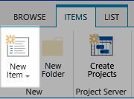

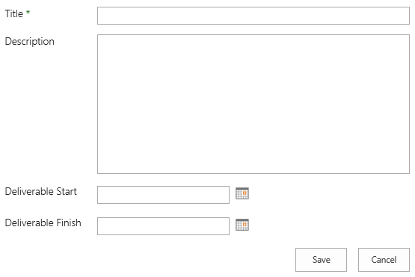

1. Deliverable Creation [Deliverable Creation.tif]
2. A new blank deliverables page will appear. Fill in the details and click Save.

To create a new deliverable in Project Professional:

1. In the File tab, click Open.
2. In the Open dialog box, double click Retrieve the list of all projects from Project Server.
3. Open the project for which you would like to create a new deliverable.
4. In the Task tab, Insert group, open the dropdown menu for Manage Deliverables and Dependencies.

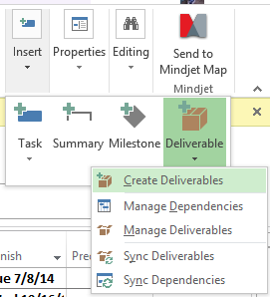

1. Create Deliverables in Project Professional [Create Deliverables in Project Pro.tif]
2. Choose Manage Deliverables. A new Deliverables pane will open on the left side of the screen. In the pane, click Add New Deliverable.

Figure#?? 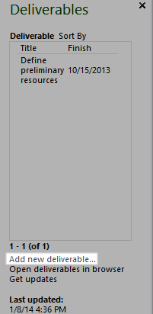 Add New Deliverable Pane [Add New Deliverable Pane.tif]

1. Enter the deliverable title, start and finish dates, and click Done.
2. In order to add an existing task from a project as a deliverable, select the task and from the Manage Deliverables and Dependencies dropdown menu, choose Create Deliverables. The selected task will be created as a deliverable and a corresponding icon will appear in the indicator column for the selected task.

## Linking Deliverables to a Task

A deliverable can be independent or associated with a task or phase in Project 2010. It is possible that the deliverables of one project will affect another project, and thus deliverables need to be tracked. It is important to note that the dates of the tasks are not tied to the dates of the deliverable. If a deliverable date is missed, it will just show a visual indication and not impact the project schedule.

To link a deliverable to a task:

1. Open the project with deliverables associated. In the Task tab, Insert group, open the dropdown menu for Manage Deliverables and Dependencies, and choose Manage Deliverables.

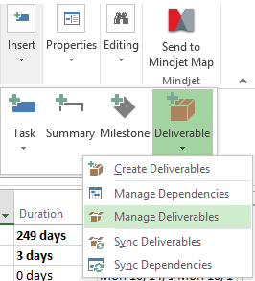

1. Manage Deliverables [Manage Deliverables.tif]
2. The Deliverable pane will appear on the left. Select the task and right click the deliverable to be linked to the task.
3. Choose Edit Deliverable and select the Link to Selected Task checkbox.

An icon will appear next to the task indicating it has a linked deliverable. A Gantt bar will also be displayed with the start and finish dates of the deliverable.

## Updating Deliverables

A red exclamation point is displayed to the left of the deliverable name in the Deliverables pane when a deliverable in your project plan is not in sync with the updates on the Project Site.

To update deliverables and dependencies changes:

1. Open the project with the deliverables associated. In the Task tab, Insert group, open the dropdown menu for Manage Deliverables and Dependencies and choose Sync Deliverables. This option will update all your deliverables in the project with the latest changes on the Project Site.

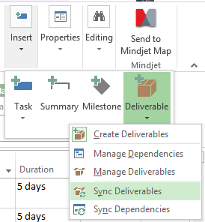

1. Sync Deliverables [Sync Deliverables.tif]

* Alternatively, if you want to accept changes one deliverable at a time, in the Deliverables pane, click the deliverable that is out of sync with the server, indicated by a red exclamation point, and click Accept Changes from Server.

# Key Points to Remember

* Project Sites, based in SharePoint, provide a communication and collaboration hub for project teams.
* Documents, images and pictures can be stored on a Project Site in libraries.
* Project documents in the document library can be managed through check in and check out features. Editing is limited to the user who has the account checked out. Preventing simultaneous editing helps streamline revisions and lessen confusion.
* List items, such as risks, issues and deliverables, can be linked to tasks providing additional information to assist the project team in managing tasks and work.
* Discussion boards provide an asynchronous opportunity to collect feedback from project team members.